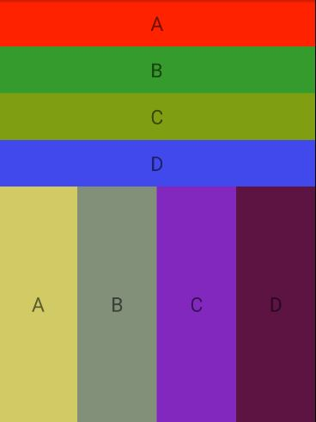

*<?***xml version="1.0" encoding="utf-8"***?>*<**LinearLayout  
 xmlns:tools="http://schemas.android.com/tools"  
 xmlns:android="http://schemas.android.com/apk/res/android"  
 android:layout_width="match_parent"  
 android:layout_height="match_parent"  
 android:paddingLeft="0dp"  
 android:paddingRight="0dp"  
 android:orientation="vertical"** >  
  
 tools:context=".MainActivity">  
  
 <**LinearLayout  
 android:layout_weight="5"  
 android:layout_width="match_parent"  
 android:layout_height="0dp"  
 android:orientation="vertical"**>  
   
 <**TextView  
 android:layout_weight="2"  
 android:layout_width="match_parent"  
 android:layout_height="0dp"  
 android:text="A"  
 android:background="#EA0C0C"  
 android:gravity="center"  
 android:textSize="30sp"** />  
 <**TextView  
 android:layout_weight="2"  
 android:layout_width="match_parent"  
 android:layout_height="0dp"  
 android:text="B"  
 android:background="#74DC4B"  
 android:gravity="center"  
 android:textSize="30sp"** />  
 <**TextView  
 android:layout_weight="2"  
 android:layout_width="match_parent"  
 android:layout_height="0dp"  
 android:text="C"  
 android:background="#FFEB3B"  
 android:gravity="center"  
 android:textSize="30sp"** />  
 <**TextView  
 android:layout_weight="2"  
 android:layout_width="match_parent"  
 android:layout_height="0dp"  
 android:text="D"  
 android:background="#2B7CFA"  
 android:gravity="center"  
 android:textSize="30sp"** />  
  
  
 </**LinearLayout**>  
  
 <**LinearLayout  
 android:layout_weight="5"  
 android:layout_width="match_parent"  
 android:layout_height="0dp"  
 android:orientation="horizontal"**>  
  
 <**TextView  
 android:layout_weight="2"  
 android:background="#FFEB3B"  
 android:layout_width="0dp"  
 android:text="A"  
 android:gravity="center"  
 android:textSize="30sp"  
 android:layout_height="match_parent"**/>  
  
  
 <**TextView  
 android:layout_weight="2"  
 android:background="#83837E"  
 android:layout_width="0dp"  
 android:text="B"  
 android:gravity="center"  
 android:textSize="30sp"  
 android:layout_height="match_parent"**/>  
 <**TextView  
 android:layout_weight="2"  
 android:background="#B025D6"  
 android:layout_width="0dp"  
 android:text="C"  
 android:gravity="center"  
 android:textSize="30sp"  
 android:layout_height="match_parent"**/>  
 <**TextView  
 android:layout_weight="2"  
 android:background="#3C1723"  
 android:layout_width="0dp"  
 android:text="D  
"  
 android:gravity="center"  
 android:textSize="30sp"  
 android:layout_height="match_parent"**/>  
  
  
 </**LinearLayout**>

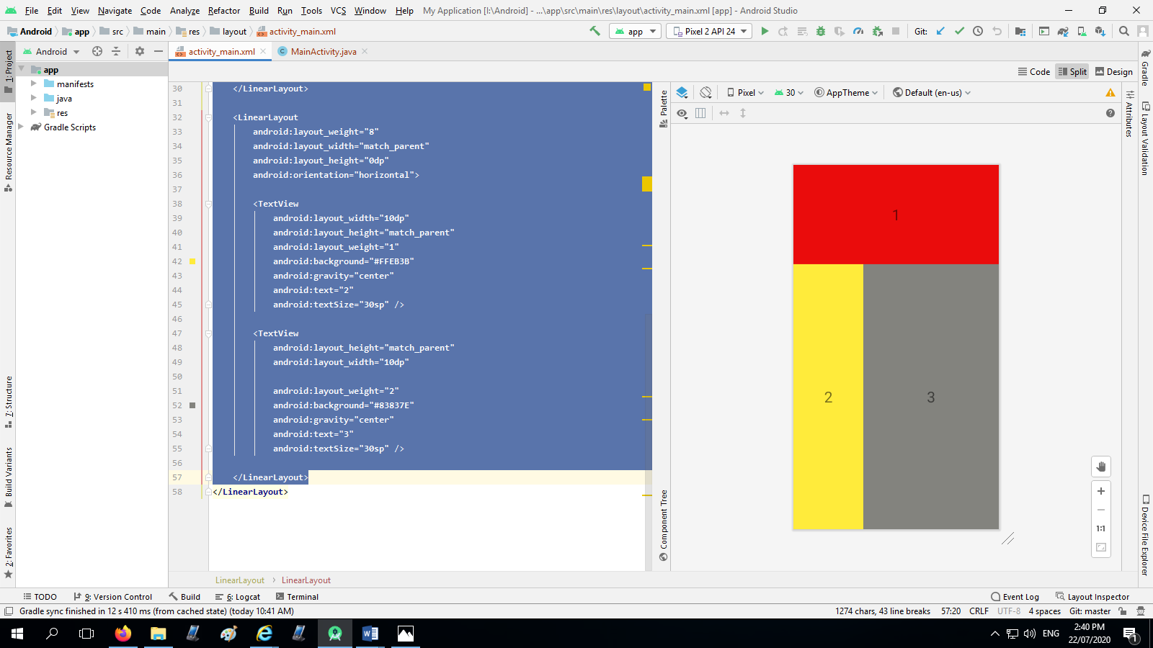

<**LinearLayout  
 android:layout_weight="3"  
 android:layout_width="match_parent"  
 android:layout_height="0dp"  
 android:orientation="vertical"**>  
  
 <**TextView  
 android:layout_weight="2"  
 android:layout_width="match_parent"  
 android:layout_height="0dp"  
 android:text="1"  
 android:background="#EA0C0C"  
 android:gravity="center"  
 android:textSize="30sp"** />  
  
</**LinearLayout**>  
  
<**LinearLayout  
 android:layout_weight="8"  
 android:layout_width="match_parent"  
 android:layout_height="0dp"  
 android:orientation="horizontal"**>  
  
 <**TextView  
 android:layout_width="10dp"  
 android:layout_height="match_parent"  
 android:layout_weight="1"  
 android:background="#FFEB3B"  
 android:gravity="center"  
 android:text="2"  
 android:textSize="30sp"** />  
  
 <**TextView  
 android:layout_height="match_parent"  
 android:layout_width="10dp"  
   
 android:layout_weight="2"  
 android:background="#83837E"  
 android:gravity="center"  
 android:text="3"  
 android:textSize="30sp"** />  
  
</**LinearLayout**>

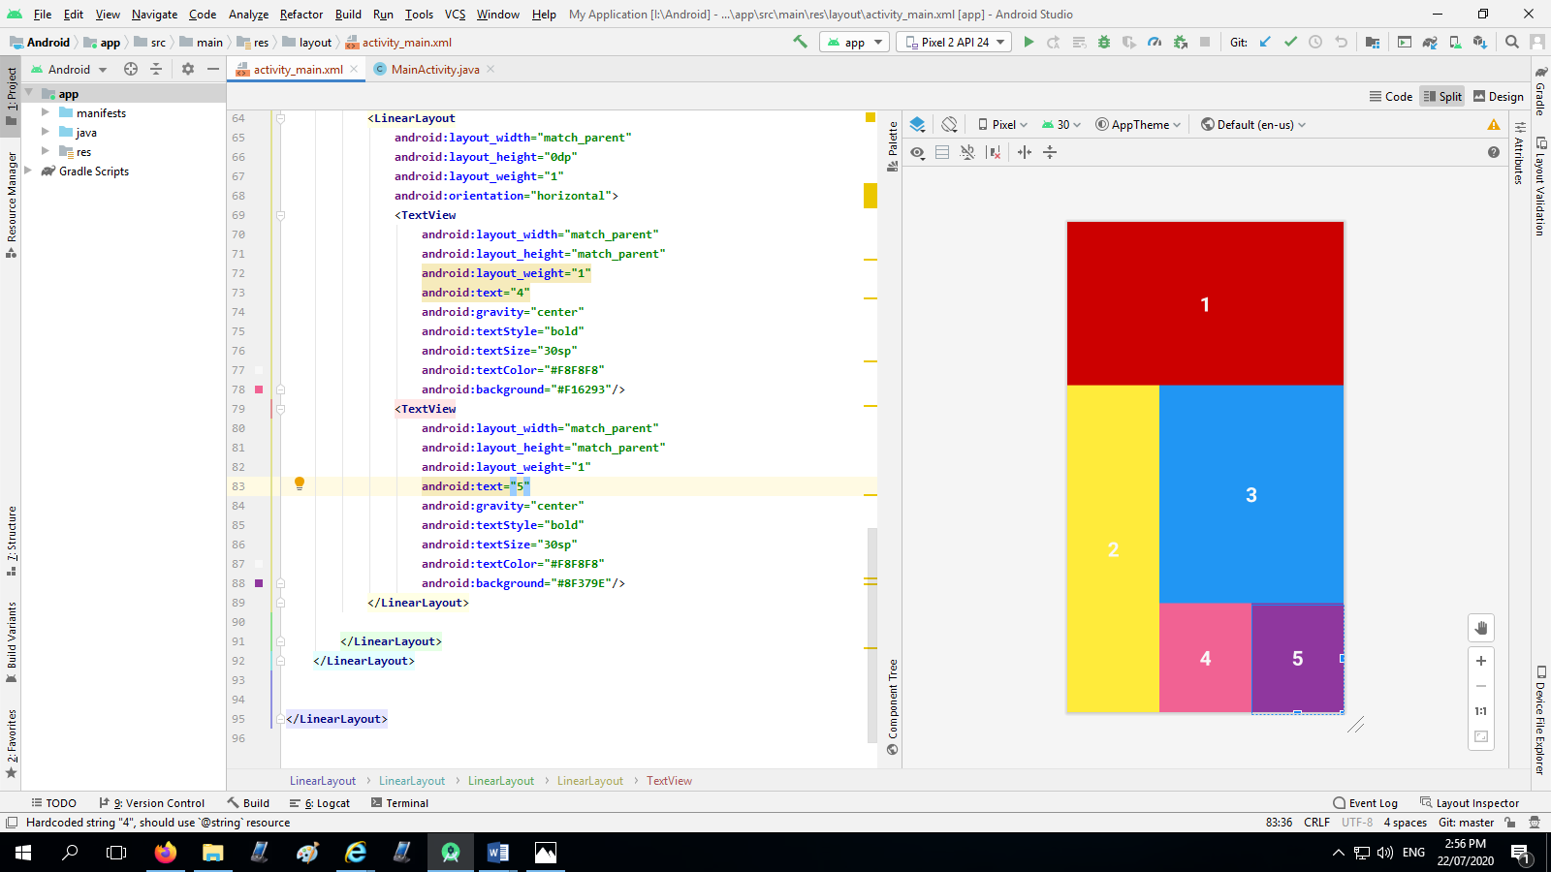

*<?***xml version="1.0" encoding="utf-8"***?>*<**LinearLayout  
 xmlns:tools="http://schemas.android.com/tools"  
 xmlns:android="http://schemas.android.com/apk/res/android"  
 android:layout_width="match_parent"  
 android:layout_height="match_parent"  
 android:paddingLeft="0dp"  
 android:paddingRight="0dp"  
 android:orientation="vertical"** >  
 android:weightSum="3"  
  
 tools:context=".MainActivity">  
  
 <**LinearLayout  
 android:layout_width="match_parent"  
 android:layout_height="0dp"  
 android:background="#CC0000"  
 android:layout_weight="1"**>  
 <**TextView  
 android:layout_width="match_parent"  
 android:layout_height="match_parent"  
 android:text="1"  
 android:textColor="#F4F4F4"  
 android:textSize="30sp"  
 android:textStyle="bold"  
 android:gravity="center"**/>  
 </**LinearLayout**>  
 <**LinearLayout  
 android:layout_width="match_parent"  
 android:layout_height="0dp"  
 android:layout_weight="2"  
 android:orientation="horizontal"  
 android:weightSum="3"**>  
 <**LinearLayout  
 android:layout_width="0dp"  
 android:layout_height="match_parent"  
 android:background="#FFEB3B"  
 android:layout_weight="1"**>  
 <**TextView  
 android:layout_width="match_parent"  
 android:layout_height="match_parent"  
 android:gravity="center"  
 android:textStyle="bold"  
 android:textSize="30sp"  
 android:text="2"  
 android:textColor="#F8F8F8"**/>  
 </**LinearLayout**>  
 <**LinearLayout  
 android:layout_width="0dp"  
 android:layout_height="match_parent"  
 android:orientation="vertical"  
 android:layout_weight="2"  
 android:weightSum="3"**>  
 <**TextView  
 android:layout_width="match_parent"  
 android:layout_height="0dp"  
 android:background="#2196F3"  
 android:layout_weight="2"  
 android:text="3"  
 android:gravity="center"  
 android:textStyle="bold"  
 android:textSize="30sp"  
 android:textColor="#F8F8F8"**/>  
 <**LinearLayout  
 android:layout_width="match_parent"  
 android:layout_height="0dp"  
 android:layout_weight="1"  
 android:orientation="horizontal"**>  
 <**TextView  
 android:layout_width="match_parent"  
 android:layout_height="match_parent"  
 android:layout_weight="1"  
 android:text="4"  
 android:gravity="center"  
 android:textStyle="bold"  
 android:textSize="30sp"  
 android:textColor="#F8F8F8"  
 android:background="#F16293"**/>  
 <**TextView  
 android:layout_width="match_parent"  
 android:layout_height="match_parent"  
 android:layout_weight="1"  
 android:text="5"  
 android:gravity="center"  
 android:textStyle="bold"  
 android:textSize="30sp"  
 android:textColor="#F8F8F8"  
 android:background="#8F379E"**/>  
 </**LinearLayout**>  
  
 </**LinearLayout**>  
 </**LinearLayout**>  
  
  
</**LinearLayout**>

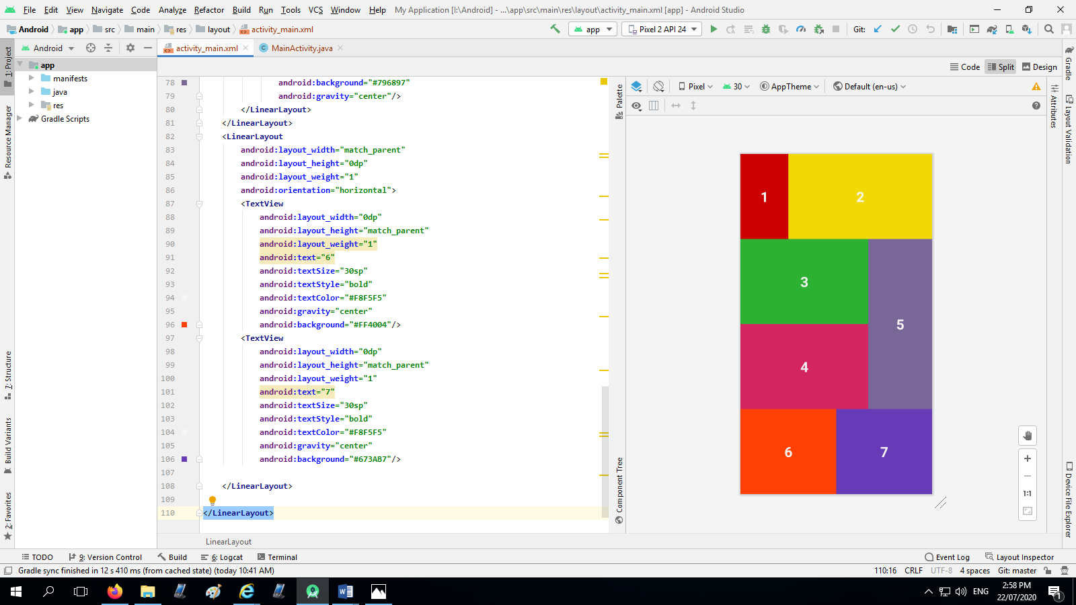

<**LinearLayout  
 android:layout_width="match_parent"  
 android:layout_height="match_parent"  
 android:orientation="vertical"  
 android:weightSum="4"  
 xmlns:android="http://schemas.android.com/apk/res/android"**>  
 <**LinearLayout  
 android:layout_width="match_parent"  
 android:layout_height="0dp"  
 android:orientation="horizontal"  
 android:layout_weight="1"  
 android:weightSum="4"**>  
 <**TextView  
 android:layout_width="0dp"  
 android:layout_height="match_parent"  
 android:background="#CC0000"  
 android:layout_weight="1"  
 android:text="1"  
 android:textColor="#FAF7F7"  
 android:textSize="30sp"  
 android:textStyle="bold"  
 android:gravity="center"**/>  
 <**TextView  
 android:layout_width="0dp"  
 android:layout_height="match_parent"  
 android:background="#F1D907"  
 android:layout_weight="3"  
 android:text="2"  
 android:textColor="#FAF7F7"  
 android:textSize="30sp"  
 android:textStyle="bold"  
 android:gravity="center"**/>  
 </**LinearLayout**>  
 <**LinearLayout  
 android:layout_width="match_parent"  
 android:layout_height="0dp"  
 android:layout_weight="2"  
 android:weightSum="3"  
 android:orientation="horizontal"**>  
 <**LinearLayout  
 android:layout_width="0dp"  
 android:layout_height="match_parent"  
 android:orientation="vertical"  
 android:layout_weight="2"**>  
 <**TextView  
 android:layout_width="match_parent"  
 android:layout_height="0dp"  
 android:layout_weight="1"  
 android:text="3"  
 android:textStyle="bold"  
 android:textSize="30sp"  
 android:textColor="#F3F0F0"  
 android:background="#2DB132"  
 android:gravity="center"**/>  
 <**TextView  
 android:layout_width="match_parent"  
 android:layout_height="0dp"  
 android:layout_weight="1"  
 android:text="4"  
 android:textStyle="bold"  
 android:textSize="30sp"  
 android:textColor="#F3F0F0"  
 android:background="#D32560"  
 android:gravity="center"**/>  
 </**LinearLayout**>  
 <**LinearLayout  
 android:layout_width="0dp"  
 android:layout_height="match_parent"  
 android:layout_weight="1"**>  
 <**TextView  
 android:layout_width="match_parent"  
 android:layout_height="match_parent"  
 android:text="5"  
 android:textColor="#FAF6F6"  
 android:textSize="30sp"  
 android:textStyle="bold"  
 android:background="#796897"  
 android:gravity="center"**/>  
 </**LinearLayout**>  
 </**LinearLayout**>  
 <**LinearLayout  
 android:layout_width="match_parent"  
 android:layout_height="0dp"  
 android:layout_weight="1"  
 android:orientation="horizontal"**>  
 <**TextView  
 android:layout_width="0dp"  
 android:layout_height="match_parent"  
 android:layout_weight="1"  
 android:text="6"  
 android:textSize="30sp"  
 android:textStyle="bold"  
 android:textColor="#F8F5F5"  
 android:gravity="center"  
 android:background="#FF4004"**/>  
 <**TextView  
 android:layout_width="0dp"  
 android:layout_height="match_parent"  
 android:layout_weight="1"  
 android:text="7"  
 android:textSize="30sp"  
 android:textStyle="bold"  
 android:textColor="#F8F5F5"  
 android:gravity="center"  
 android:background="#673AB7"**/>  
  
 </**LinearLayout**>  
  
</**LinearLayout**>

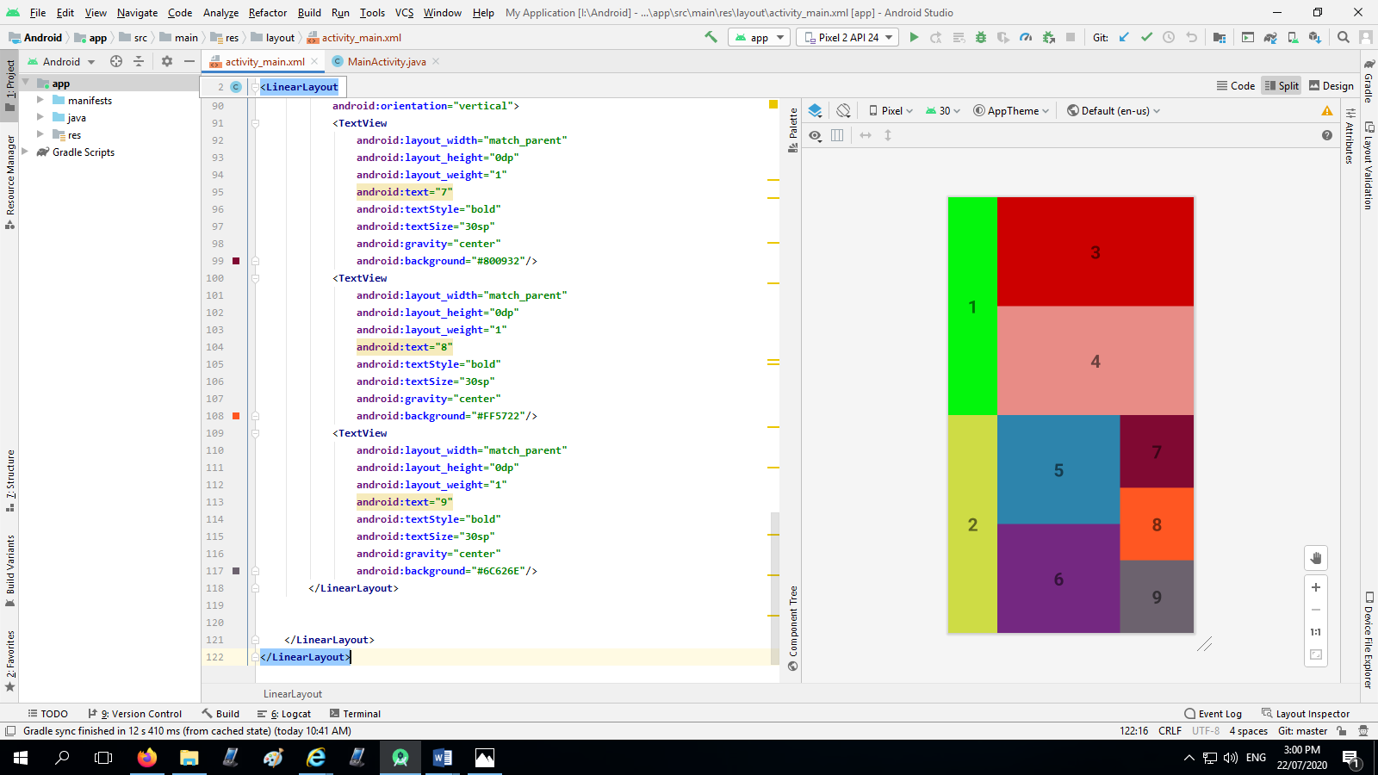

<**LinearLayout  
 android:layout_width="match_parent"  
 android:layout_height="match_parent"  
 android:orientation="vertical"  
 xmlns:android="http://schemas.android.com/apk/res/android"**>  
 <**LinearLayout  
 android:layout_width="match_parent"  
 android:layout_height="0dp"  
 android:orientation="horizontal"  
 android:layout_weight="1"  
 android:weightSum="5"**>  
 <**TextView  
 android:layout_width="0dp"  
 android:layout_height="match_parent"  
 android:text="1"  
 android:textSize="30sp"  
 android:textStyle="bold"  
 android:background="#02F60C"  
 android:layout_weight="1"  
 android:gravity="center"**/>  
 <**LinearLayout  
 android:layout_width="0dp"  
 android:layout_height="match_parent"  
 android:layout_weight="4"  
 android:orientation="vertical"**>  
 <**TextView  
 android:layout_width="match_parent"  
 android:layout_height="0dp"  
 android:text="3"  
 android:textStyle="bold"  
 android:textSize="30sp"  
 android:gravity="center"  
 android:layout_weight="1"  
 android:background="#CC0000"**/>  
 <**TextView  
 android:layout_width="match_parent"  
 android:layout_height="0dp"  
 android:text="4"  
 android:textStyle="bold"  
 android:textSize="30sp"  
 android:gravity="center"  
 android:layout_weight="1"  
 android:background="#E88C86"**/>  
 </**LinearLayout**>  
 </**LinearLayout**>  
 <**LinearLayout  
 android:layout_width="match_parent"  
 android:layout_height="0dp"  
 android:layout_weight="1"  
 android:orientation="horizontal"  
 android:weightSum="5"**>  
 <**TextView  
 android:layout_width="0dp"  
 android:layout_height="match_parent"  
 android:layout_weight="1"  
 android:text="2"  
 android:textSize="30sp"  
 android:textStyle="bold"  
 android:gravity="center"  
 android:background="#CEDC45"**/>  
 <**LinearLayout  
 android:layout_width="0dp"  
 android:layout_height="match_parent"  
 android:layout_weight="2.5"  
 android:orientation="vertical"**>  
 <**TextView  
 android:layout_width="match_parent"  
 android:layout_height="0dp"  
 android:layout_weight="1"  
 android:text="5"  
 android:textStyle="bold"  
 android:textSize="30sp"  
 android:gravity="center"  
 android:background="#2D84AC"**/>  
 <**TextView  
 android:layout_width="match_parent"  
 android:layout_height="0dp"  
 android:layout_weight="1"  
 android:text="6"  
 android:textStyle="bold"  
 android:textSize="30sp"  
 android:gravity="center"  
 android:background="#742881"**/>  
 </**LinearLayout**>  
 <**LinearLayout  
 android:layout_width="0dp"  
 android:layout_height="match_parent"  
 android:layout_weight="1.5"  
 android:orientation="vertical"**>  
 <**TextView  
 android:layout_width="match_parent"  
 android:layout_height="0dp"  
 android:layout_weight="1"  
 android:text="7"  
 android:textStyle="bold"  
 android:textSize="30sp"  
 android:gravity="center"  
 android:background="#800932"**/>  
 <**TextView  
 android:layout_width="match_parent"  
 android:layout_height="0dp"  
 android:layout_weight="1"  
 android:text="8"  
 android:textStyle="bold"  
 android:textSize="30sp"  
 android:gravity="center"  
 android:background="#FF5722"**/>  
 <**TextView  
 android:layout_width="match_parent"  
 android:layout_height="0dp"  
 android:layout_weight="1"  
 android:text="9"  
 android:textStyle="bold"  
 android:textSize="30sp"  
 android:gravity="center"  
 android:background="#6C626E"**/>  
 </**LinearLayout**>  
  
  
 </**LinearLayout**>  
</**LinearLayout**>

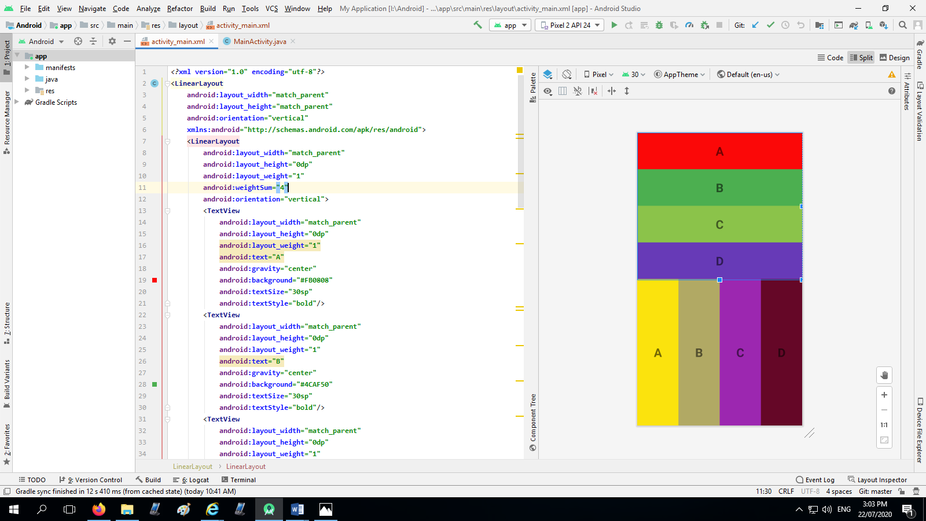.

<**LinearLayout  
 android:layout_width="match_parent"  
 android:layout_height="match_parent"  
 android:orientation="vertical"  
 xmlns:android="http://schemas.android.com/apk/res/android"**>  
 <**LinearLayout  
 android:layout_width="match_parent"  
 android:layout_height="0dp"  
 android:layout_weight="1"  
 android:weightSum="4"  
 android:orientation="vertical"**>  
 <**TextView  
 android:layout_width="match_parent"  
 android:layout_height="0dp"  
 android:layout_weight="1"  
 android:text="A"  
 android:gravity="center"  
 android:background="#FB0808"  
 android:textSize="30sp"  
 android:textStyle="bold"**/>  
 <**TextView  
 android:layout_width="match_parent"  
 android:layout_height="0dp"  
 android:layout_weight="1"  
 android:text="B"  
 android:gravity="center"  
 android:background="#4CAF50"  
 android:textSize="30sp"  
 android:textStyle="bold"**/>  
 <**TextView  
 android:layout_width="match_parent"  
 android:layout_height="0dp"  
 android:layout_weight="1"  
 android:text="C"  
 android:gravity="center"  
 android:background="#8BC34A"  
 android:textSize="30sp"  
 android:textStyle="bold"**/>  
 <**TextView  
 android:layout_width="match_parent"  
 android:layout_height="0dp"  
 android:layout_weight="1"  
 android:text="D"  
 android:gravity="center"  
 android:background="#673AB7"  
 android:textSize="30sp"  
 android:textStyle="bold"**/>  
 </**LinearLayout**>  
 <**LinearLayout  
 android:layout_width="match_parent"  
 android:layout_height="0dp"  
 android:layout_weight="1"  
 android:weightSum="4"  
 android:orientation="horizontal"**>  
 <**TextView  
 android:layout_width="0dp"  
 android:layout_height="match_parent"  
 android:background="#FBE30D"  
 android:layout_weight="1"  
 android:text="A"  
 android:textStyle="bold"  
 android:textSize="30sp"  
 android:gravity="center"**/>  
 <**TextView  
 android:layout_width="0dp"  
 android:layout_height="match_parent"  
 android:background="#B1A964"  
 android:layout_weight="1"  
 android:text="B"  
 android:textStyle="bold"  
 android:textSize="30sp"  
 android:gravity="center"**/>  
 <**TextView  
 android:layout_width="0dp"  
 android:layout_height="match_parent"  
 android:background="#9C27B0"  
 android:layout_weight="1"  
 android:text="C"  
 android:textStyle="bold"  
 android:textSize="30sp"  
 android:gravity="center"**/>  
 <**TextView  
 android:layout_width="0dp"  
 android:layout_height="match_parent"  
 android:background="#650727"  
 android:layout_weight="1"  
 android:text="D"  
 android:textStyle="bold"  
 android:textSize="30sp"  
 android:gravity="center"**/>  
 </**LinearLayout**>  
</**LinearLayout**>